About this template

This template contains information about the required structure of your paper for inclusion in the Journal of Southern Hemisphere Earth Systems Science (JSHESS) and displays the format that the publisher requires you to use.

To use this template, please highlight a field and overwrite the provided information with your text.

This template is set up to allow easy flow of content into the final laid out format of the paper. Please use this template for your final submission if possible.

Remember to add the manuscript ID and the lead author’s name in the footer.

Delete the text in this box when you are ready to submit.

Paper title
Author First name Surname^{A,*}, First name Surname^{B} and First name Surname^{A}
^{A}Affiliation, including department, university, city, state, country as a minimum.
^{B}Affiliation, including department, university, city, state, country as a minimum.
*Correspondence to. Email: xxx@email.com
Abstract. The abstract (~250 words for a research article) should be a complete summary of the paper’s ‘story’, i.e. context; aim; methods; key results; conclusions (that can be drawn from the key results); implications (from the conclusions) that affect the wider field. Open with a clear statement of the broad context of the work, briefly summarise the aims and research approach, give the principal findings, and conclude by specifying the main implications of the results. It is important to end by pointing readers towards how this research might be useful in a broad context. Avoid including references and abbreviations in the abstract; if abbreviations cannot be avoided, define them at first use.
Keywords: insert a minimum of eight keywords to aid online discoverability
TOC Summary: The short summary is a three-sentence paragraph of 50 to 80 words written for interested non-experts, such as journalists, teachers, government workers, etc. The text should be free from scientific jargon, and written at the level of an article in a science magazine. Your first sentence should engage the reader, convincing them that this is an important area. The second sentence should introduce the problem addressed in the paper, and state your main discovery. The final sentence should describe how the results fit into the bigger picture (i.e. implications or impact of the discovery). If supplying an accompanying image, provide a credit as the final line of your summary (i.e. Photograph by J. Bloggs).

1 Introduction
The journal uses numbered sections. Open your paper with an introduction. The introduction should set the scene for the work in the opening sentences. The following text should only cover essential background literature and clearly indicate the reason for the work. This section should close with a paragraph specifying aims and, where appropriate, testable hypotheses. For grammar and language style, refer to the publication Style Manual for Authors, Editors and Printers of Australian Government Publications (6th edition, 2002), and to recent issues of the journal.
Subheadings can be used throughout your text. Headings other than those indicated here can be used depending on your paper type. Headings and sub headings are numbered in JSHESS. Styles for subheadings are

1.1 Heading level 2

1.1.1 Heading level 3

2 Methods
In the Methods (or Materials and methods), sufficient detail should be given to enable the work to be repeated. If a commercial product such as an analytical instrument is mentioned, supply its full model name and location of the manufacturer at the first appearance. Give complete citations and version numbers for computer software. Methods sections are usually reported in past tense.

2.1 Abbreviations
Please define abbreviations at first use in the text, for example ‘using generalised estimate equations (GEEs)’. If an abbreviation was defined in the abstract, please define it again at first use in the main text.

2.2 In text citations
Figures should be cited in text as follows (Fig. 1), and tables similarly (Table 1). References should be cited using Harvard style, for a single author please use (Bloggs 2019), for two authors (Bloggs and Doe 2020), for 3+ authors use (Smith et al. 2020). If citing a list of references, please provide them chronologically with citations separated by a semi-colon (Bloggs 2019; Bloggs and Doe 2020; Smith et al. 2020). If referencing a home page of a website, or a continuously updated page (i.e. one without a publication date) please provide the URL in the text (http://website.com) and not in the reference list.
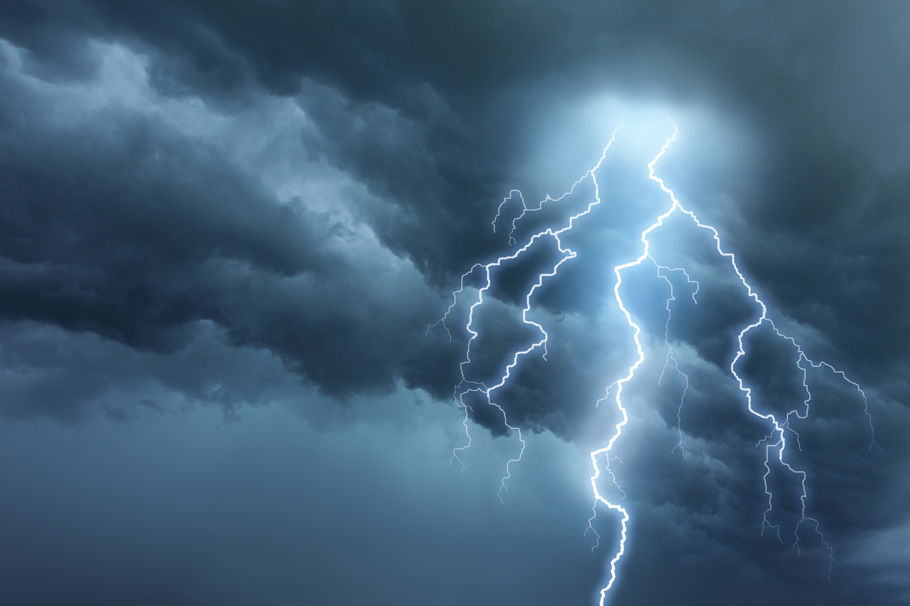<SAMPLE FIGURE>
Fig. 1. Explain your figures fully in the captions. Figure parts should be described as (a) shows ABC and (b) shows XYZ. If using photographs provide a photographer credit (i.e. Photograph by Joe Bloggs). Ensure appropriate permissions have been gained if using figures that are not the authors’ own. See https://www.publish.csiro.au/es/forauthors/AuthorInstructions#22 for more information on figure preparation.
Table 1. Here is a table. Provide a concise explanation of your table in the table title.
Term | Estimate | s.e. | W | Pr (> W)
Intercept | –4.220^{A} | 0.276 | 234.4 | < 2 e-16 *
Chl-a max | 1.892 | 0.466 | 16.5 | 4.8 e-05 *
Note: If there is additional information pertinent to the whole table it should be explained in a table footnote. Abbreviations can also be defined here.
^{A}If there is information relating to a specific cell it should be cited with an uppercase letter and listed under any general footnotes.
*Significance levels are indicated by asterisks.

2.2.1 Supplementary material
Supplementary material of a detailed nature that may be useful to other readers, but is not essential to the published paper, may be made available online. If there is online supplementary material available with your paper you should refer to it in the text as ‘Table S1/Fig. S1, available as Supplementary material’.

2.3 Numbers, units
Please spell out numbers <10 unless they are being used with a unit. Numbers ≥10 should be written in numerals. Please use a thin space to separate large numbers >9999, no comma is required in numbers <9999.
Use SI units for all measurements unless there are valid reasons for not doing so – these will need full explanation. Units can be provided using the solidus (mL/day) or using the negative exponent format (mL day^{–1}), but aim for consistent use throughout your paper. Avoid ambiguous forms of expression such as mL/m²/day.
Words and symbols for units should not be mixed; in general, symbols should be used only when preceded by a number (thus ‘10 m’, but ‘several metres’). Unit symbols are not punctuated, i.e. they are not treated as abbreviations; the same symbol is used for both singular and plural. Note that, although the Kelvin is the SI unit of temperature, the degree sign must be used when writing temperatures or temperature differences in the Celsius scale, i.e. ‘272 K’, but ‘22°C’.
Day, month and year are written ‘29 December 1959’ (do not abbreviate names of months). The recommended time zone is Coordinated Universal Time, abbreviated UTC. Time, time zone, day, month and year are written ‘2330 UTC 29 December 1959’, in some instances the use of other time zones is permissible, for example, AEST (150°E meridian civil time).

2.4 Equations
Equations can, where appropriate, be included inline with the main body text. Where this is not possible, equations should be provided in an editable format and displayed in the centre of the page with an equation number as shown below. Equations should be cited in the text where needed in the format, Eqn 1.
(1)

3 Results
Results should be stated concisely and without interpretation (although in complex studies, modest interpretation of some data may provide context helpful for understanding subsequent sections). Data presented should address the aims and testable hypotheses raised in the Introduction. Use tables and figures to illustrate the key points but do not repeat their contents in detail. In general use past tense to describe experiments completed and present tense to refer to tables and figures.

4 Discussion
The Discussion should explain the scientific significance of the results in context with the literature, clearly distinguishing factual results from speculation and interpretation. Avoid excessive use of references – more than three to support a claim is usually unnecessary. Limitations of methods should also be addressed where appropriate. Conclude the Discussion with a section on the implications of the findings. Footnotes are discouraged and should be used only when essential. In general use past tense to summarise your findings, present tense to interpret results.

5 Conclusion
A separate conclusion section can be included if preferred.

Data availability
Include a data availability statement. A number is not needed for this section, nor any of the back matter. For advice on completing this section see https://www.publish.csiro.au/journals/publishingpolicies#6

Conflicts of interest
Include a conflicts statement. If none, please use ‘The authors declare that they have no conflicts of interest.’

Declaration of funding
Include a statement of funding. If no specific funding was received, please add ‘This research did not receive any specific funding’.

Acknowledgments
Provide all necessary acknowledgements.

References
Antonov JI, Seidov D, Boyer TP, Locarnini RA, Mishonov AV, Garcia HE, Baranova OK, Zweng MM, Johnson DR (2010) World Ocean Atlas 2009, Volume 2: Salinity. In ‘NOAA Atlas NESDIS 69’. (Ed. S Levitus) 184 pp. (US Government Printing Office: Washington, DC)
Bi D, Dix M, Marsland S, O’Farrell S, Sullivan A, Bodman R, Law R, Harman I, Srbinovsky J, Rashid H, Dobrohotoff P, Mackallah C, Yan H, Hirst A, Savita A, Dias FB, Woodhouse M, Fiedler R, Heerdegen A (2020) Configuration and spin-up of ACCESS-CM2, the new generation Australian Community Climate and Earth System Simulator Coupled Model. Journal of Southern Hemisphere Earth Systems Science (In press). doi:10.1071/ES19040
Bureau National Operations Centre (2016) APS2 Upgrade to the ACCESSR Numerical Weather Prediction System. Melbourne, Australia. Available at: http://www.bom.gov.au/australia/charts/bulletins/apob107-external.pdf
Chen L, Zhu Q, Luo H (1991) ‘East Asian Monsoon.’ (China Meteorological Press: Beijing) [In Chinese]
Craig A, Valcke S, Coquart L (2017) Development and performance of a new version of the OASIS coupler, OASIS3-MCT_3.0. Geoscientific Model Development 10, 3297–3308. doi:10.5194/GMD-10-3297-2017
Ding Y (2004) Seasonal march of the East-Asian summer monsoon. In ‘East Asian Monsoon.’ (Ed. CP Chang.) pp. 3–53. (World Scientific: Singapore)
IPCC (2013) Climate change 2013: The physical science basis. Contribution of Working Group I to the Fifth Assessment Report of the Intergovernmental Panel on Climate Change. (Eds TF Stocker, D Qin, GK Plattner, M Tignor, SK Allen, J Boschung, A Nauels, Y Xia, V Bex, PM Midgley) Cambridge University Press, Cambridge, United Kingdom and New York, NY, USA.
Mo R, Geng Q, Brugman M, Pearce G, Goosen J, Snyder B (2009) Collision of a Pineapple Express with an arctic outbreak over complex terrains of British Columbia, Canada – Forecast challenges and lessons learned. In ‘23rd Conference on Weather Analysis and Forecasting’, 1–5 June 2009 Omaha, NE, USA. American Meteorological Society. Available at https://ams.confex.com/ams/pdfpapers/154212.pdf

